API Documentation

1. Get All Transactions

**Endpoint:** api/transactionsget  
**Description:** Retrieves all transactions.

**Response:** 200 OK

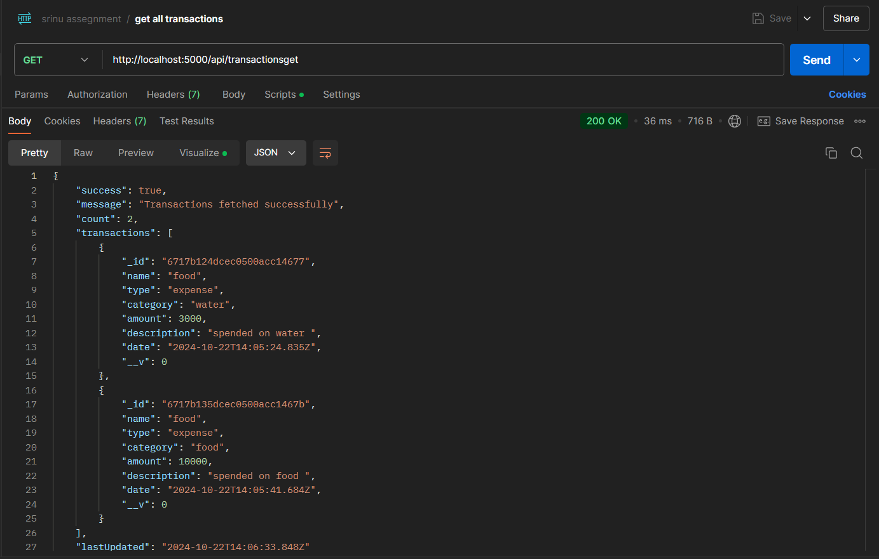

**Visualize:**

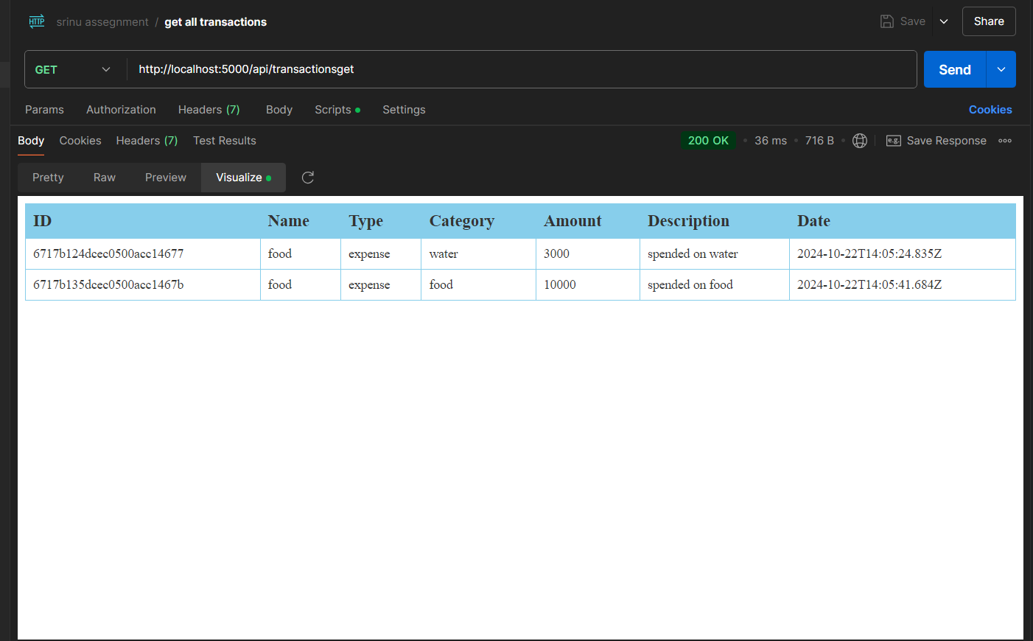

**2. Create a New Transaction**

**Endpoint:** api/transactions **Description:** Creates a new transaction.

**Request Body:**

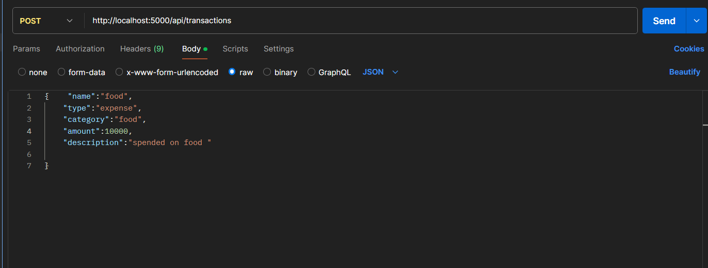

**Response:** 201 Created

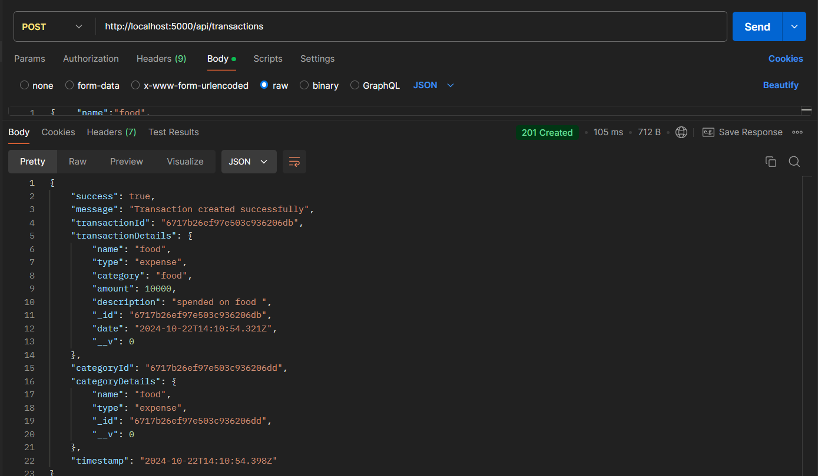

**400 Bad Request :**

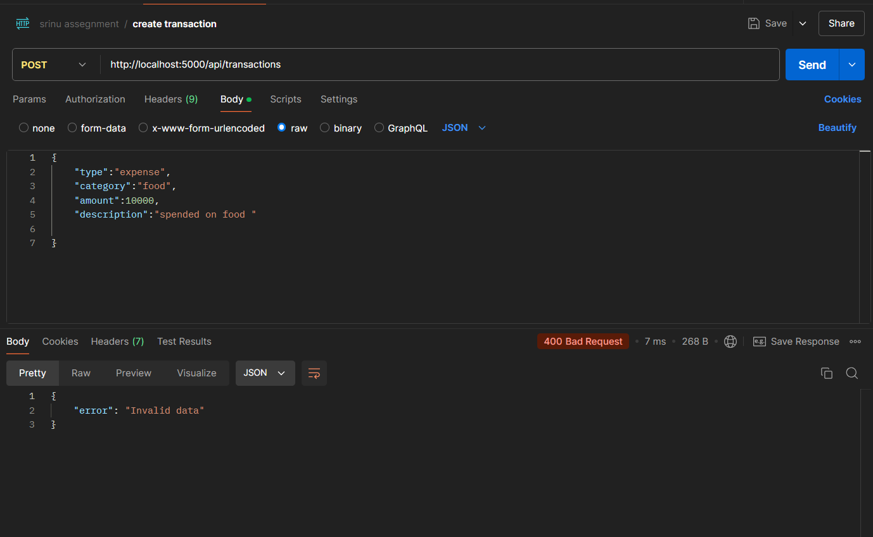

**3. Get Transaction by ID**

**Endpoint:** api/transactions/:id **Description: Retrieves a transaction by its ID.**

**Response:** 200 OK

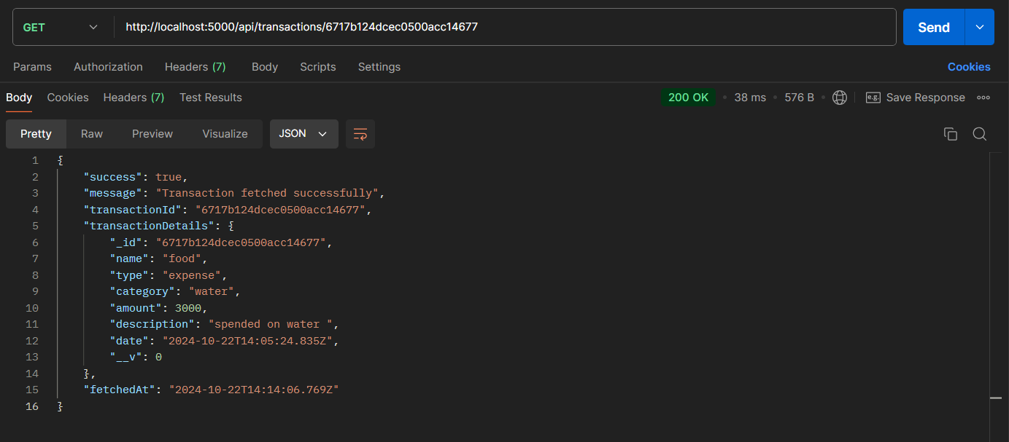

**404 Not Found**

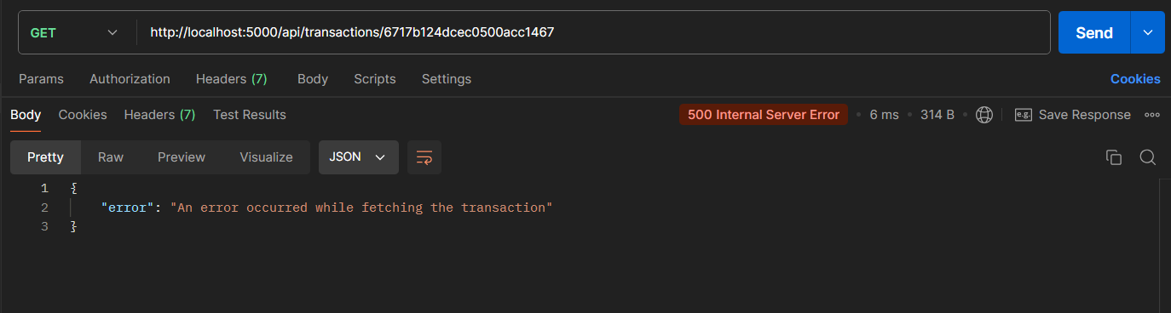

**4. Update a Transaction**

**Endpoint:** PUT /transactions/:id **Description:** Updates an existing transaction by its ID.

**Request Body:**

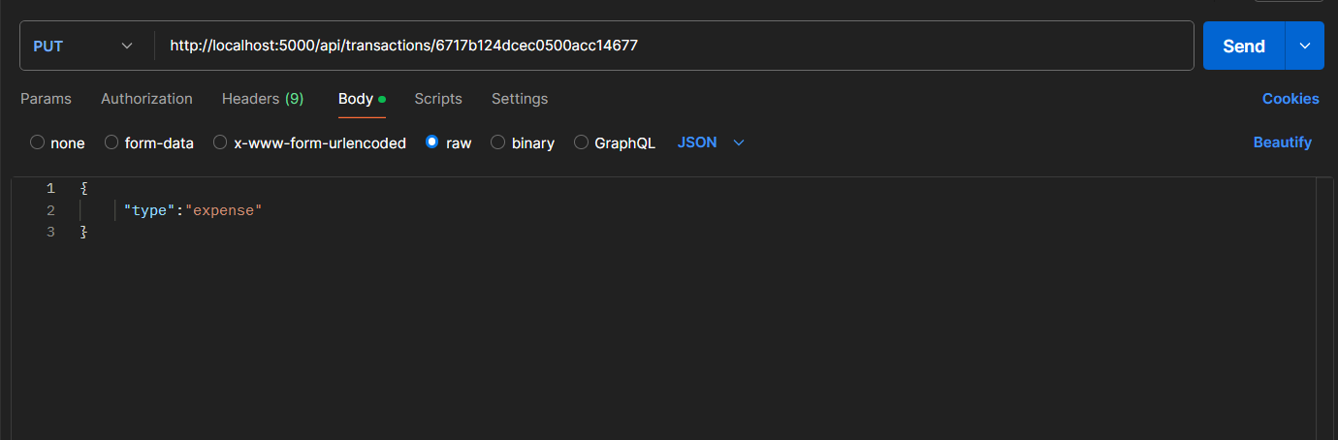

**Response:** 200 OK

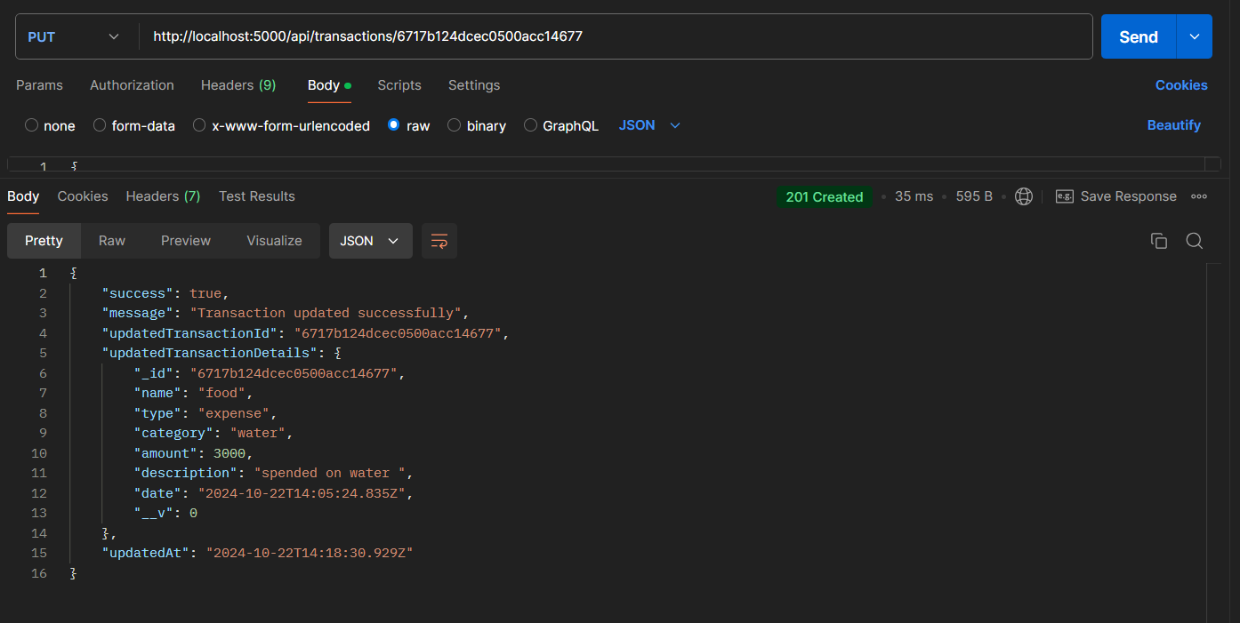

**404 Not Found**

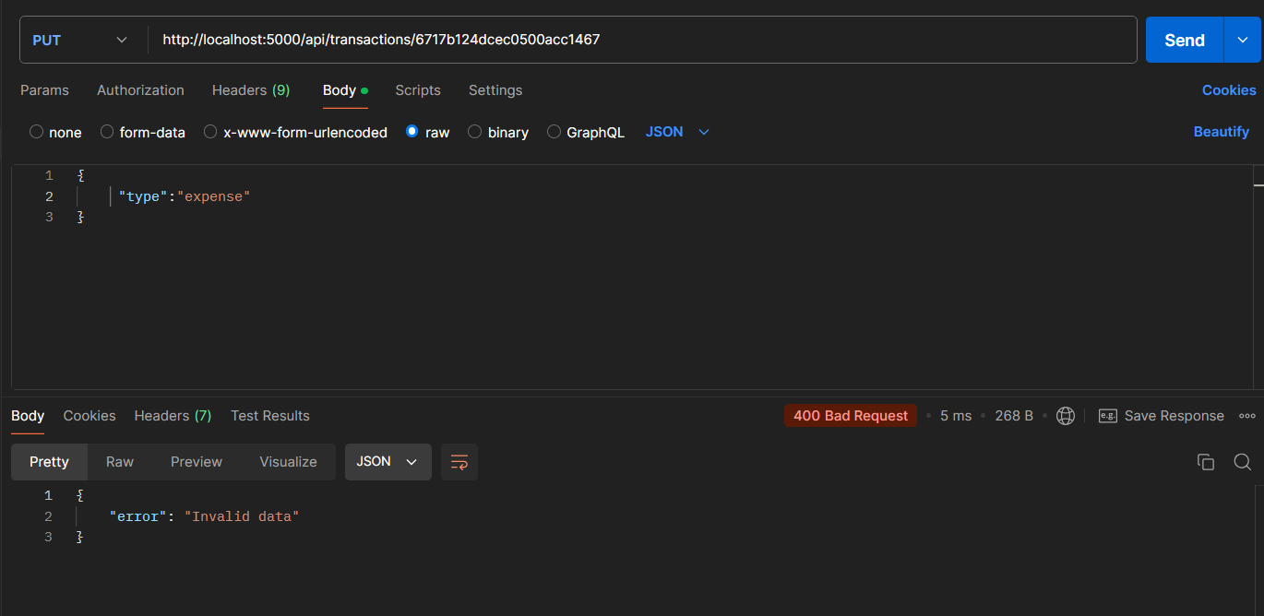

**5. Delete a Transaction**

**Endpoint:** api/transactions/:id  **Description:** Deletes a transaction by its ID.

**Response:** 200 OK

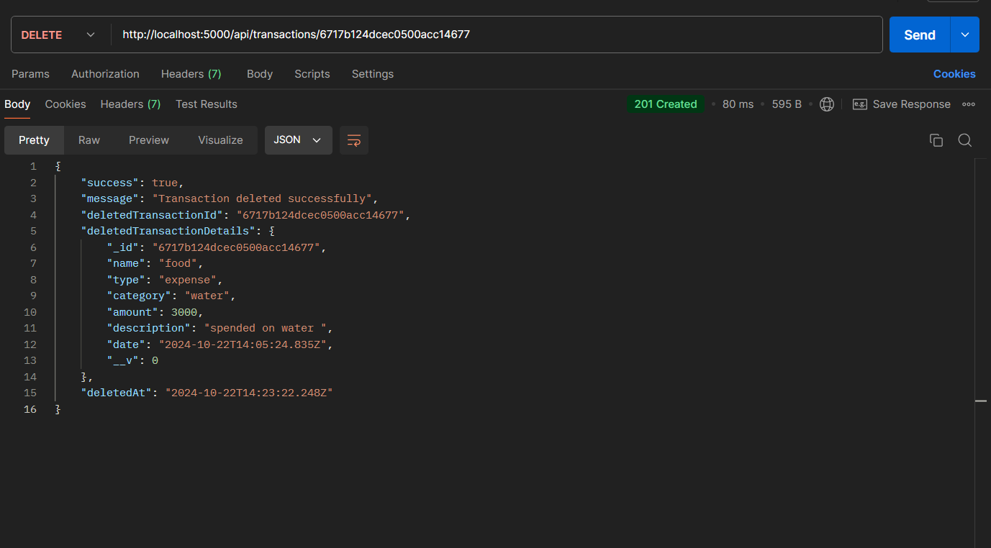

**404 Not Found**

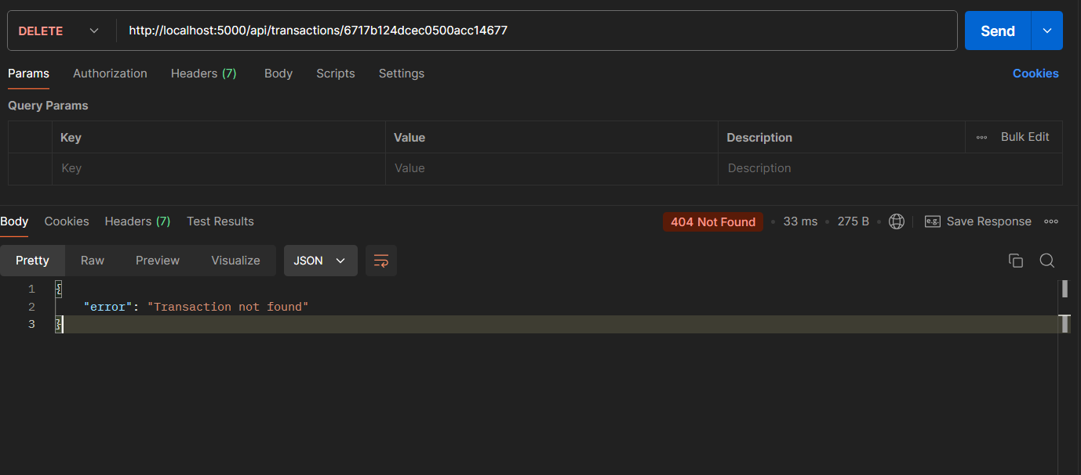

**6. Get Transaction Summary**

**Endpoint:** api/summary **Description:** Retrieves a summary of transactions, such as total income, total expenses, and balance.

**Response:** 200 OK

